### 

### Semester One Examination, 2021

### Question/Answer booklet

# MATHEMATICS SPECIALIST

**UNIT 3**

## Section One:

## Calculator-free

|  |
| --- |
|  |

Your Name

Your Teacher’s Name

## Time allowed for this section

Reading time before commencing work: five minutes

Working time: fifty minutes

## Materials required/recommended for this section

***To be provided by the supervisor***

This Question/Answer booklet

Formula sheet

***To be provided by the candidate***

Standard items: pens (blue/black preferred), pencils (including coloured), sharpener, correction fluid/tape, eraser, ruler, highlighters

Special items: nil

## Important note to candidates

No other items may be taken into the examination room. It is **your** responsibility to ensure that you do not have any unauthorised material. If you have any unauthorised material with you, hand it to the supervisor **before** reading any further.

|  |  |  |  |  |  |
| --- | --- | --- | --- | --- | --- |
| Question | Mark | Max | Question | Mark | Max |
| 1 |  |  | 5 |  |  |
| 2 |  |  | 6 |  |  |
| 3 |  |  | 7 |  |  |
| 4 |  |  | 8 |  |  |

**Structure of this paper**

|  |  |  |  |  |  |
| --- | --- | --- | --- | --- | --- |
| Section | Number of questions available | Number of questions to be answered | Working time (minutes) | Marks available | Percentage of examination |
| Section One:  Calculator-free | 8 | 8 | 50 | 50 | 34 |
| Section Two:  Calculator-assumed | 14 | 14 | 100 | 96 | 66 |
|  |  |  |  | **Total** | 100 |

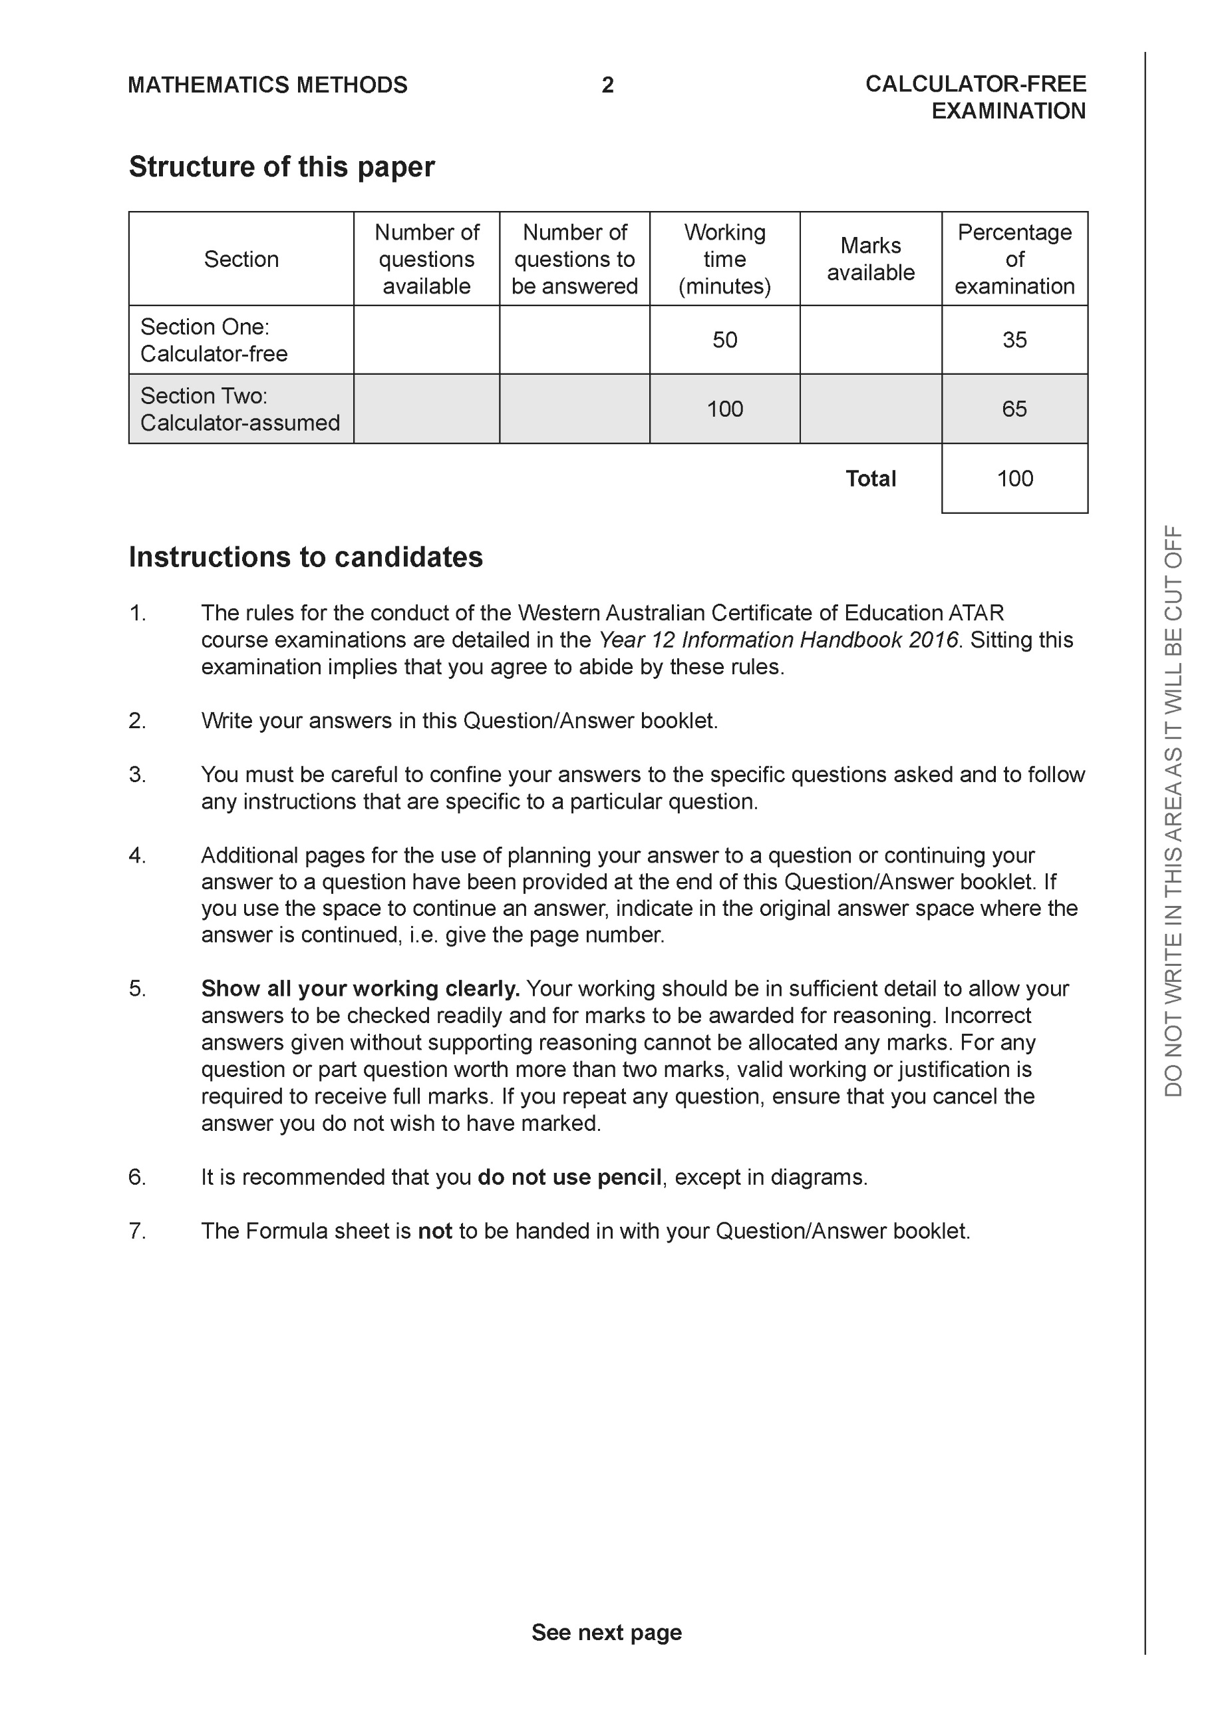

**Section One: Calculator-free (50 Marks)**

This section has **eight (8)** questions. Answer **all** questions. Write your answers in the spaces provided.

Spare pages are included at the end of this booklet. They can be used for planning your responses and/or as additional space if required to continue an answer.

● Planning: If you use the spare pages for planning, indicate this clearly at the top of the page.

● Continuing an answer: If you need to use the space to continue an answer, indicate in the original answer space where the answer is continued, i.e. give the page number. Fill in the number of the question that you are continuing to answer at the top of the page.

Working time: 50 minutes.

**Question 1 (6 marks)**

Consider the plane  which contains point A 

(a) Write a vector equation for this plane. (3 marks)

|  |
| --- |
| **Solution** |
|  |
| **Specific behaviours** |
| 🗸 identifies a normal vector  🗸 shows dot product to determine scalar constant  🗸 uses correct format for vector equation |

Consider the line 

(b) Determine the coordinates of where the line above meets the plane. (3 marks)

|  |
| --- |
| **Solution** |
|  |
| **Specific behaviours** |
| 🗸 sets up dot product equation  🗸 solves for parameter  🗸 subs parameter back into equation (no need to simplify) |

**Question 2 (6 marks)**

Sketch the graph  where . Clearly show the major features of the graph.

|  |
| --- |
| **Solution** |
|  |
| **Specific behaviours** |
| 🗸 shows both vertical asymptotes  🗸 shows both x intercepts(exact)  🗸 shows approx. y intercept  🗸 shows horizontal asymptote  🗸 two of the three parts have correct shape  🗸 all parts have correct shape |

**Question 3 (6 marks)**

Consider the plane  that contains the following three points . Using vector methods, determine the distance of point  from the plane . Show all working and reasoning.

|  |
| --- |
| **Solution** |
|  |
| **Specific behaviours** |
| 🗸 determines two vectors in plane  🗸 uses cross product to find a normal  🗸 Determines a vector from D to any point on plane OR uses a line through D parallel to normal  🗸 uses dot product or finds intersection of line & plane  🗸 uses unit normal or solves for parameter of line  🗸determines exact distance(accept irrational denominator) |
|  |

**Question 4 (5 marks)**

Consider the function  as graphed below.

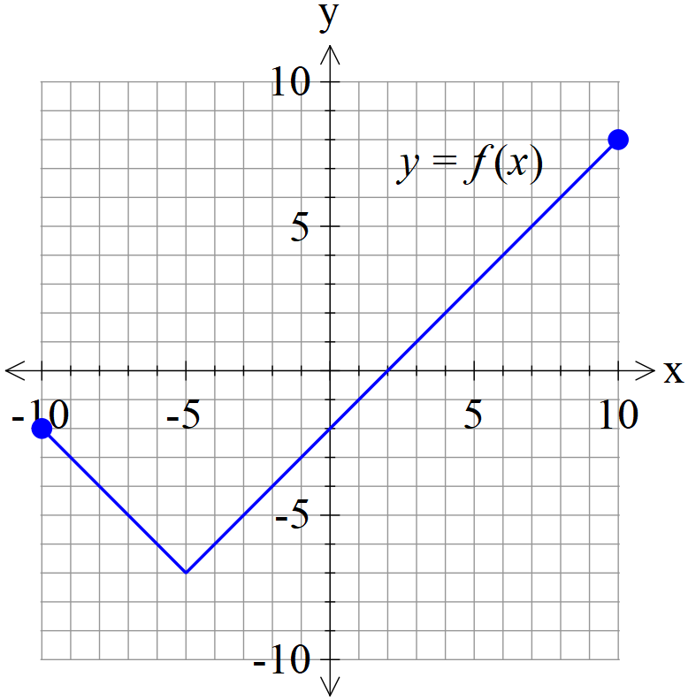

1. Graph  on the axes below. (2 marks)

|  |
| --- |
| **Solution** |
|  |
| **Specific behaviours** |
| 🗸 reflects one side  🗸 correct graph |

1. Graph  on the axes below. (3 marks)

|  |
| --- |
| **Solution** |
|  |
| **Specific behaviours** |
| 🗸 shows asymptote  🗸 approx. y intercept and min turning pt at x=-5 ( do not accept max)  🗸 correct shape on both sides of asymptote |

**Question 5 (7 marks)**

Consider the function  with domain 

(a) Determine  and its domain. (4 marks)

|  |
| --- |
| **Solution** |
|  |
| **Specific behaviours** |
| 🗸 swaps x & y OR solves for x as subject  🗸 uses a quadratic formula expression OR completes the square  🗸 uses minus and states domain of inverse (no need to simplify)  🗸 states rule for inverse |

(b) Consider  with  and  real constants. Given that  has an inverse which intersects graphically with  at one point only, determine a possible exact solution for in terms of and an equation that must satisfy.

(3 marks)

|  |
| --- |
| **Solution** |
|  |
| **Specific behaviours** |
| 🗸 equates function to x  🗸 uses quadratic formula to give one answer only  🗸 uses discriminant equaling zero |

**Question 6 (7 marks)**

Consider the following system of linear equations.



1. Solve for . (3 marks)

|  |
| --- |
| **Solution** |
|  |
| **Specific behaviours** |
| 🗸 eliminates one variable for two equations  🗸 eliminates two variables for one equation  🗸 solves for all three variables |

Q6 cont-

1. If we modify the equations to the following with  being constants, solve for the following values of such that there are:
2. no solutions
3. infinite solutions (Give a geometrical interpretation of this situation) (4 marks)



|  |
| --- |
| **Solution** |
| No solns p=-7 and  Infinite p=-7 and  Line of common points that lie on all 3 planes |
| **Specific behaviours** |
| 🗸 eliminates two variables  🗸 states all values for no solns  🗸 states values for infinite solns  🗸with geometric explanation |

**Question 7 (10 marks)**

1. Solve for all solutions to the following  in the form  with .

(4 marks)

|  |
| --- |
| **Solution** |
|  |
| **Specific behaviours** |
| 🗸 determines argument of right hand side (third quadrant)  🗸 uses De Moivre’s Theorem with arguments in increments of  🗸 six roots with correct modulus  🗸 six roots, all with correct principal arguments |

1. Plot the above roots on the diagram below, labelling the axes. (3 marks)

|  |
| --- |
| **Solution** |
|  |
| **Specific behaviours** |
| 🗸 one point at correct position  🗸 scale indicated  🗸 six points equally spaced |

1. If these points are joined, forming a polygon, determine the exact area of this polygon.

(3 marks)

|  |
| --- |
| **Solution** |
|  |
| **Specific behaviours** |
| 🗸 uses equilateral triangles with side length equaled to modulus of roots  🗸 determines area of one triangle  🗸 states total area as an exact expression. (no need to simplify) |

**Question 8 (3 marks)**

Sketch the locus of points that satisfy  on the complex plane below and explain your reasoning.

|  |
| --- |
| **Solution** |
|  |
| **Specific behaviours** |
| 🗸 uses a line segment  🗸 correct endpoints  🗸 indicates the two arguments on diagram showing a difference of pi radians |

Additional working space

Question number:

Additional working space

Question number:

Additional working space

Question number:

**Acknowledgements**